MCA 2nd Semester

Name:-Lakshita Joshi

Roll no.:-16

Subject:-Cloud Computing

Topic:-Azure Bastion

**What is Azure Bastion?**

Azure Bastion is a service that allows you to securely connect to your virtual machines (VMs) in Azure without exposing them to the public internet. It provides secure and seamless RDP/SSH connectivity to your VMs directly through the Azure portal or via native SSH/RDP clients already installed on your local computer.

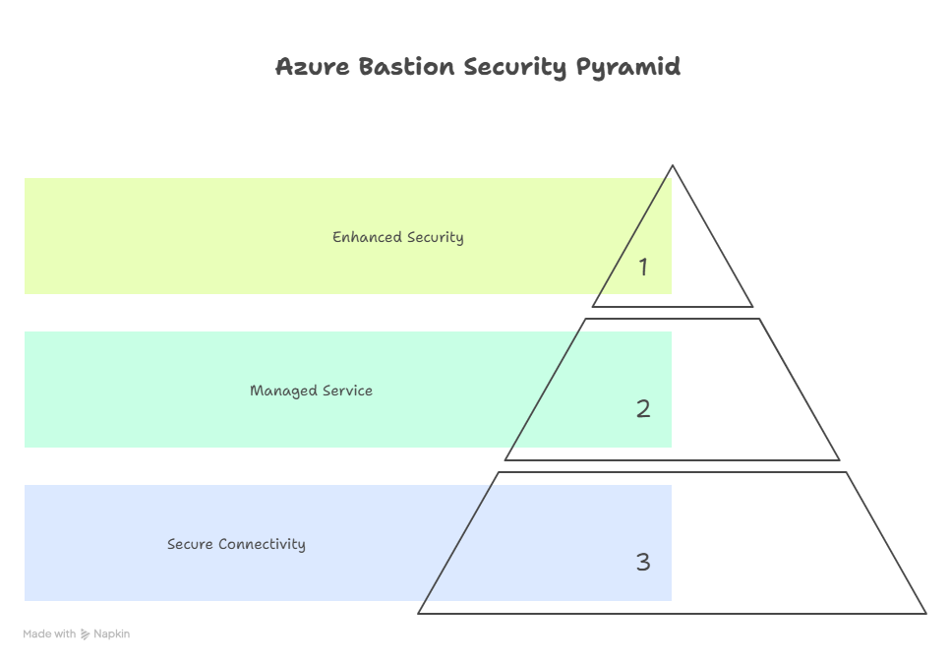

**Key Features and Benefits:**

* **Enhanced Security:** Azure Bastion eliminates the need for public IP addresses on your VMs, significantly reducing the attack surface and protecting them from external threats. It centralizes access control and provides a single point of entry for managing remote access.
* **Simplified Management:** Azure Bastion simplifies the management of remote access by providing a centralized and secure platform. It eliminates the need for managing jump boxes or VPN gateways, reducing operational overhead and complexity.
* **Seamless Connectivity:** Azure Bastion provides a seamless and user-friendly experience for connecting to VMs. Users can connect directly through the Azure portal or via native SSH/RDP clients, without requiring any additional software or configuration.
* **Reduced Cost:** Azure Bastion can help reduce costs by eliminating the need for public IP addresses on VMs and reducing the operational overhead associated with managing jump boxes or VPN gateways.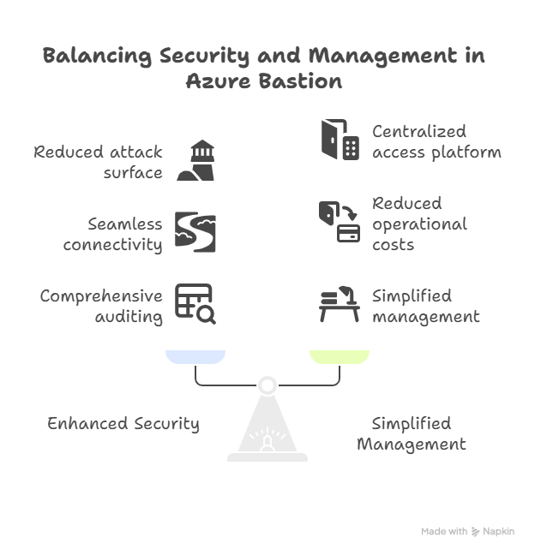
* **Auditing and Monitoring:** Azure Bastion provides comprehensive auditing and monitoring capabilities, allowing you to track user activity and identify potential security threats.

**Architecture**

Azure Bastion is deployed within your virtual network and acts as a secure gateway for connecting to your VMs. The architecture consists of the following components:

* **Bastion Host:** The Bastion host is a fully managed Azure resource that provides secure RDP/SSH connectivity to your VMs. It is deployed within your virtual network and has a public IP address that is used for inbound connections.
* **Virtual Network:** The virtual network is the private network in Azure where your VMs are deployed. Azure Bastion is deployed within the same virtual network as your VMs.
* **Subnet:** Azure Bastion requires a dedicated subnet within your virtual network. This subnet is used to host the Bastion host and must be named AzureBastionSubnet.
* **Network Security Group (NSG):** Network Security Groups (NSGs) are used to control network traffic to and from the Bastion host. NSGs can be configured to allow only authorized users to connect to the Bastion host.
* **Azure Portal/Native Clients:** Users can connect to VMs through the Azure portal or via native SSH/RDP clients. The connection is established through the Bastion host, which acts as a secure gateway.

